October 2021

Dear Applicant

Teaching Assistant

Thank you for your interest in the above post. Please find enclosed information about our school, the personnel specification and job description.

The deadline for applications is Monday 1st November at 12pm.

You are very welcome to look around the school prior to making your application. Please contact the school office to arrange a visit.

We look forward to receiving your application.

Yours sincerely

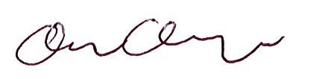

Clare Cosgrove
Head of School

